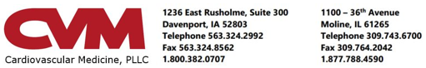x
__________________________________________________________________________________________________________________
PATIENT: Candy Test
ACCOUNT #: 379655
__________________________________________________________________________________________________________________
Cardiac PET MPI Stress test

This test takes approximately 1 1/2 hours.

_____ Davenport Diagnostic Center _____ Moline Diagnostic Center
2nd Floor, Genesis Heart Institute CVM Heart Center
1236 East Rusholme 1100 36th Avenue
Davenport, IA 52803 Moline, IL 61265
(563) 324-2992 (309) 743-6700

Your test is scheduled on: DATE: __________________ TIME: ____________________

- Please read these instructions carefully. Failure to follow these instructions may require the test to be rescheduled.

- Each time a patient misses an appointment without providing notice, another patient is prevented from receiving care. We ask that you please give at least a 24-hour notice if you are unable to keep your appointment. If you do not keep your appointment and do not notify us in advance, a $75 charge will be assessed to your account. This charge must be paid prior to rescheduling.

- If your insurance has changed since the time your test was scheduled, please check with your current insurer to see if test pre-certification is required.

What is a cardiac PET stress test?
A positron emission tomography (PET) scan is a type of imaging test that helps determine how your heart is functioning. The test involves injecting a small amount of a radioactive medicine into a vein of your arm. This test is used to evaluate the blood supply to the heart muscle during periods of rest and stress. The arteries that supply blood to the heart muscle can become clogged or narrowed from the buildup of plaque. The images allow the doctor to see if the heart is receiving adequate blood supply during rest and stress. The stress test is performed with a medicine called Regadenoson. The Regadenoson mimics exercise by temporarily increasing the size of the coronary arteries.

How to prepare for the test:
- No food or drink 4 hours prior to this test. Sips of water to moisten your mouth are acceptable. If you are a diabetic, please ask your doctor about fasting and taking your diabetic medications.
- No caffeine for 12 hours prior to your test. If you consume any amount of caffeine within 12 hours of your test, your test will be rescheduled. Please see the list of caffeine products and medications that must be held for this test. Caffeine-free and decaffeinated products contain trace amounts of caffeine and must be avoided.
- This test may be problematic if you are claustrophobic or have a fear of tight spaces. Your chin to mid torso will be enclosed in the PET machine (approximately 36-inch diameter). If you believe this may be a problem, please call the office to discuss as we may be able to accommodate you.
- You will need to lie flat with your arms above your head for 20-30 minutes. During this time, your head and knees will be supported for your comfort. If you do not believe you can do this, please call the office to discuss options available to accommodate your needs.
- You should take your medications before and after this test unless instructed otherwise.
- Wear comfortable two-piece clothing. Ladies will be asked to remove their bra for imaging purposes.
- If CVM does not have a current list of your medications, please bring a list of your medications or your medication bottles with you.
- If you are pregnant or may be pregnant, please discuss this with your physician prior to the test.
- Please allow 1-1½ hours for this test.

Upon arrival at the doctor’s office…
A member of our staff will escort you to an exam room, explain the procedure, and ask you to sign a consent form. An IV line will be started in your hand or arm. The staff member will place electrode patches on your chest. You will be asked to lie flat on your back on an imaging table with your arms above your head. It is very important that you lay as still as possible during the test. The radioactive medicine and Regadenoson will be administered through the IV line and rest and stress images are obtained. Upon completion of the images the EKG patches and IV will be removed. When the test is complete you may resume your regular diet and routine. The test usually takes about 1-1½ hours to complete. A copy of your test report will be sent to your physician.

CAFFEINE products must not be consumed for 12 hours prior to a nuclear stress test. The following products may contain caffeine and should not be consumed:

Energy drinks
Coffee/Decaf Coffee
Tea/Decaf Tea
Cola/Diet Cola/Decaf Cola
Mountain Dew/Diet Mountain Dew/Decaf Mountain Dew
Mellow Yellow Orange Cola
Anacin/Excedrin/Any pain relievers containing caffeine
Any food or drink containing CHOCOLATE, such as: ice cream, yogurt, pudding, baked products, candy, cocoa, chocolate syrup and chocolate milk.

Please Note: Caffeine-Free and Decaffeinated products contain trace amounts of caffeine and must be avoided.

Medications to be held prior to regadenoson stress testing:

The following prescription medications should not be taken for 48 hours prior to your test time.

Dipyridamole (Persantine, Dipridacot), Aggrenox

Breathing medications known as xanthines should not be taken for 24 hours prior to your test time. These include:

Theophylline Slo-Bid Theo-24 Slo-Phylline
Uni-dur Theodur Uniphyl

Please Note: You should not quit taking any prescription medication without specific instructions from your doctor. If you have concerns about holding a medication, please ask your doctor prior to discontinuing the medication.

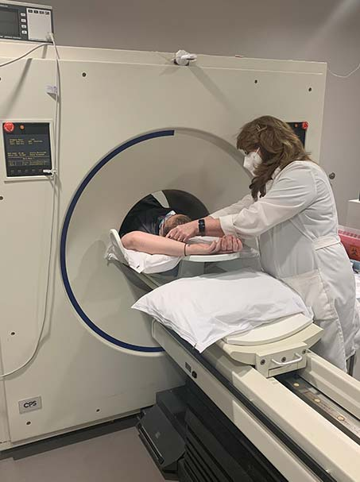
x

08/22/2022 1:52 PM

Candy Test
1111 11 Th St
Moline,, IL 61265-

Candy Test :

On March 23, 2010, President Obama signed into law the Patient Protection and Affordable Care Act. This act mandates that we inform you of other locations where you may obtain a contrast enhanced computed tomography (CTA) or Rb-82 cardiac positron emission tomography (Cardiac PET).

To our knowledge the only other providers of CTA within a 25 mile radius to CVM are:

  - Radiology Group Imaging Center, 1970 53rd St., Davenport IA, (563) 359-1131
  - Advanced Radiology, 615 Valley View Dr, Moline IL, (309) 762-1072
  - Genesis Medical Center, 1227 E. Rusholme St., Davenport IA, (563) 421-1000
  - Genesis Medical Center, 1401 W Central Park Ave, Davenport IA, (563) 421-1000
  - Genesis Medical Center, 801 Illini Dr., Silvis, IL (309) 792-9363
  - Trinity Medical Center, 500 John Deere Rd, Moline IL, (309) 779-5000
  - Trinity Medical Center, 2701 17th St., Rock Island IL, (309) 779-5000
  - Trinity Medical Center, 4500 Utica Ridge Rd, Bettendorf, IA (563) 742-5000

To our knowledge, there is no other provider of Cardiac PET within a 25 mile radius of CVM.

Thank you for considering CVM for your CTA or Cardiac PET. We are proud to provide comprehensive cardiovascular care to the Eastern Iowa and Western Illinois communities and value the opportunity to provide these services to you.

12/15/1960 MRN:000000379655

