**INSTRUCTIONS FOR TELEHEALTH OPTIONS**

We now have options to perform appointments via telephone and telephone with video. Follow Provider directives which pts. need to come to the office, have telehealth visits, or cancel/reschedule.

The grid shows the options listed with the best options on top, least favorable options as you move down the list.

**IMPORTANT NOTE:** All Telehealth Visits need to have appts. entered, checked in, encounters created, to ensure the required documentation, billing, and follow up occurs. They are not intended to be performed SOLO by Providers unless they have been trained to perform all the staff functions independently.

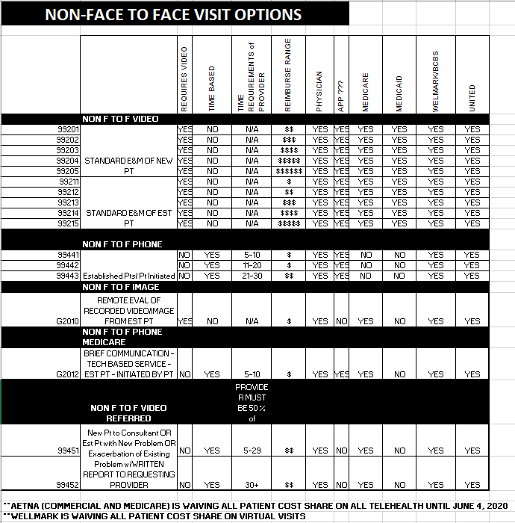

All of our major payers cover the Telehealth codes (this would include the Medicare Advantage plans as well - AARP Medicare Complete, Aetna Medicare, etc.)

Medicare

Wellmark

United Healthcare

Iowa Medicaid

Illinois Medicare

Health Partners

Humana

**WHAT DO THEY MEAN**

NON FACE TO FACE VIDEO 99201 TO 99215-

* These are the same codes that we use for New Pts. and Established Pt. in Office Visits.
* For these visits to occur, the pt. must have access to a smart phone with working video.
* The pt. needs to be worked up and documented the same as an Office Visit.
* A web-based tool called doxy.me will provide the video conference platform with the pt.
* A clinical staff person will start the call and do the “rooming” portion, then the Provider will do the assessment/plan discussion (if Provider is at home, they must enter the “rooming” data-enough to sufficiently meet the charge level submitted).
* Documentation must include verbal consent to do the visit via Telehealth (a template will help with this).
* EPM Appt. Type= NON F TO F VIDEO (NFV)
* EMR Visit Type= NON Face-to-Face
* Level of visit is determined the same as Office Visits (medical decision making, complexity). The lack of Physical Exam is already accounted for in the reimbursement.

NON FACE TO FACE TELEPHONE 99441-99443-

* These are brief visits that are initiated by established pts. We can suggest this option for them to initiate.
* Telephone visits are problem focused and do not need to meet all the documentation requirements of a full office visit.
* The Provider must do the assessment/plan discussion.
* The extent of the desired work up/”rooming” will be directed by the Provider.
* Visit is billable by time spent, which must be documented. Enter the total time spent on the Finalize template which will enter the charge and insert the required documentation. Clinical staff time is not counted.
* Documentation must include verbal consent to do the visit via Telehealth (a template will help with this).
* A modified Office Visit letter will be generated.
* EPM Appt. Type=NON F TO PHONE (NFP)
* EMR Visit Type= NON Face-to-Face
* Level of visit is determined by Provider time spent.

NON FACE TO FACE IMAGE G2010-

* These visits are initiated by the pt. We can suggest this option for them to initiate.
* Pts. may send a photo, image of a result, or a video to be reviewed and a telephone call with the provider lasting 5-10 minutes occurs to discuss the concerns.
* For Medicare pts. without a smart phone/video capability, the G2012 option could be used for a brief telephone discussion.
* Documentation must include verbal consent to do the visit via Telehealth (a template will help with this).
* A modified Office Visit letter will be generated.
* EPM Appt. Type=NON F TO F IMAGE
* EMR Visit Type= NON Face-to-Face

NON FACE TO FACE REFERRED VIDEO 99451-99452

* Pt. must be referred by another provider to be seen. May be new to practice, or established with a new problem.
* For these visits to occur, the pt. must have access to a smart phone with working video.
* The pt. needs to be worked up and documented the same as a Consult or Office Visit.
* A web-based tool called doxy.me will provide the video conference platform with the pt.
* A clinical staff person will start the call and do the “rooming” portion, then the Provider will do the assessment/plan discussion (if Provider is at home, they must enter the “rooming” data-enough to sufficiently meet the charge level submitted).
* Documentation must include verbal consent to do the visit via Telehealth (a template will help with this).
* EPM Appt. Type= NON F TO F VIDEO (NFV)
* EMR Visit Type=NON Face-to-Face
* Level of visit is determined the same as Office Visits (medical decision making, complexity)

NON-FACE-TO-FACE TCM VIDEO VISITS 99495-99496

* TCM Video Visits have all the same requirements as the Non Face-to-Face Video visits and the same requirements as TCM visits (scheduled 7/14 days after a hospital discharge and an educational/assessment phone call was completed within 2 business days.)
* EPM Appt. Type=NON F TO F TCM or NON F TO F TCM14
* EMR Visit Type=NON Face-to-Face

**NOTES-**

* Some commercial insurances will cover a phone visit the same as a video visit. If the pt. has one of these insurances, you will see a red notification to choose the LEVEL of visit instead of time spent.
* Smoking cessation counseling is an ADD ON billable code to the video visit. Additional time spent counseling needs to be entered and the appropriate counseling charge will be billed. Minimal documentation automatically occurs, but more details and recommendations need to be added to your documentation.
* Some visits cannot be billed if they are a follow up visit within the previous week.
* Some visits are not billable if they result in an office visit within 24 hours.
* Orders for testing, follow up appts., and medication changes must be entered in the EMR. Provider/staff workflow may not include the ability for conversation about orders. Providers must ensure this happens, either by entering it themselves, or by communicating with clinical staff to do the order entry or medication updates. Consider dictating with Easy NG and tasking staff.
* We may be able to offer pts. in the future to use a laptop with a webcam and use their email address to make the connection. This may not be desirable because it is more difficult for pts. to get all microphone/camera settings set up.
* If there are connectivity difficulties with video, a Telephone Visit could be considered.
* Some video alternatives are available such as Face Time or Google Duo if there are intermittent connectivity issues with cvm.doxy.me.

**CALLING PTS. TO SCHEDULE TELEHEALTH**

* Follow Provider directives which pts. need to come to the office, have telehealth visits, or cancel/reschedule.
* If appropriate for Telehealth:

Script:

Hi, this is ____ from Cardiovascular Medicine. Due to the coronavirus outbreak we are trying to protect patients from getting exposed. We now have the ability to do your appointment from home using a smart phone and video. Do you have a smart phone?  Identify if Apple or Android and note this in EMR Alerts.

(if yes) Would you like to do your visit this way?

(if yes) You do not need to download anything ahead of time.  We will send you a text at your appointment time. (Review appt. time.) There will be a link for you to tap on. You need to allow your camera to be used. Then all you need to do is follow the prompts. You will enter your name and be on hold shortly, then we will be connected and start the visit.

(if no) Do you have anyone in your household that has a smart phone that could help you?

(if no) I’m sorry, that is not going to work.  Since you do not have a smart phone, we can do an appointment with the telephone only. Would you be agreeable to that?

(if no) Proceed with canceling and rescheduling.

**NOTING SMART PHONE ACCESS IN EMR ALERTS**

* Anyone calling/fielding calls from pts., start asking and noting their Smart Phone access.
* As pts. check in for appts., make this part of the routine update of their demographic info.
* In EMR click Alerts, then Add/Edit, check the correct selection, Save & Close

Suggestion how to ask:

1. Do you have a cell phone?  If no, check Smart Phone NO.  If yes…
2. Do you have an Apple iPhone?
3. If they don’t know, ask if there is an apple on the back.  (Seriously.  We might need to do this!  ☺)
4. If not an Apple, ask if they have an Android phone.
5. If they don’t know or they tell you a strange brand name, ask if they have a camera with video capabilities, and if they can get internet on their phone.  If yes to both, choose Smart Phone Android.
6. If they say no to video camera or no to internet, mark Smart Phone NO.

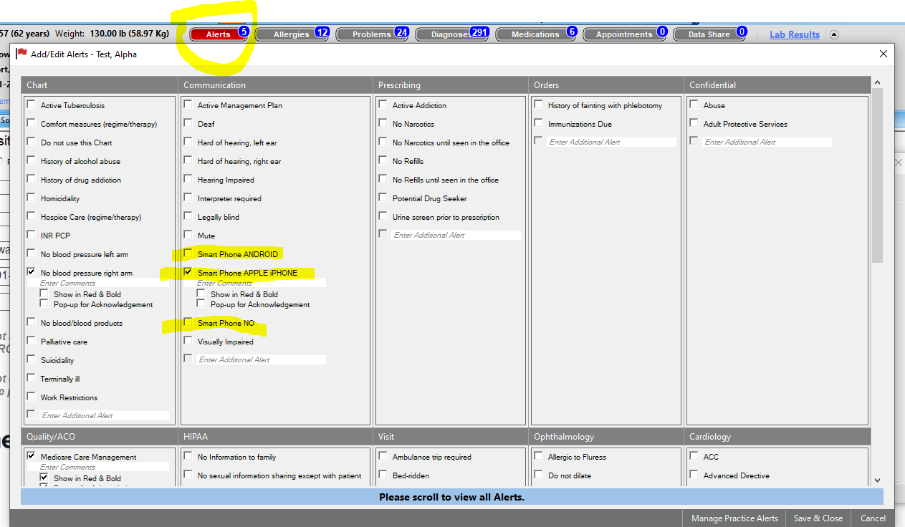

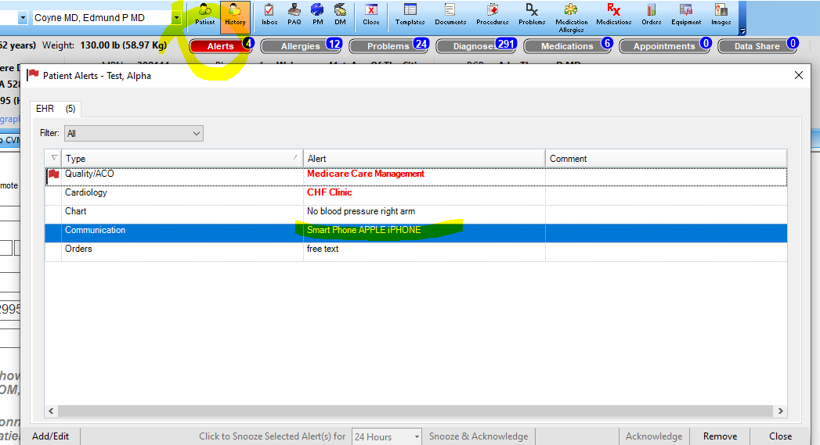

**SCHEDULING THE TELEHEALTH VISIT**

* Use the appropriate appt. type and place it on the Provider’s schedule like any other Office Visit appt.

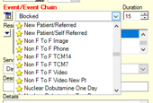 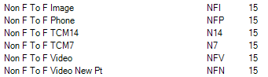

**PERFORMING THE TELEHEALTH VIDEO VISIT—**

* There will be tablets in exam rooms next to the PC. Providers may use personal tablets or laptops with cameras, or personal cell phone (screen size may not be sufficient)
* On the tablet, go to Chrome, Firefox, or Safari browser, pull up the cvm.doxy.me site and log in (info. will be on the tablet, or see below). The CVM shared tablets will automatically launch the site when the Chrome browser is opened.
* Sign in with the CVM user and password-Providers will be assigned daily which license they can use
* On the exam room PC, pull up the pt. in NextGen and open the Non Face-to-face Visit Details link on Intake, SOAP, or Home Page
* Fill in Tele and Video bullet
* Choose CVM “exam” room-Iowa or Illinois
* By the cell phone number click Send SMS
* Watch the tablet/laptop for the pt. to enter the “Waiting Room” in the upper left corner
* Click on their name and then click Start Call
* Help troubleshoot any video/audio issues (may need to ask if their camera is enabled, if sound is turned up, etc.)
* Verify the pt. gives verbal consent for the video appt.
* Check the pt. appt. in with the Check In Appt button
* Note the location of the pt. and the Provider in the template
* After the introduction, pause the video to improve performance and prevent loss of connectivity
* Verify insurance (see cheat sheet below)
* Gather meds, allergies, history, etc. like a normal office visit work up
* Call can be “paused” while waiting for Provider. Unpause when Provider joins. This puts the pt. in the “waiting room”.
* Click the name and Start Call when the Provider arrives.
* After introduction, pause video again.
* Provider perform visit discussion.
* Provider documents like a normal office visit
* Provider chooses charges with the Telehealth EM Coding button on the Finalize template and clicks Submit like usual.

**CHOOSE THE NON FACE TO FACE VISIT TYPE**

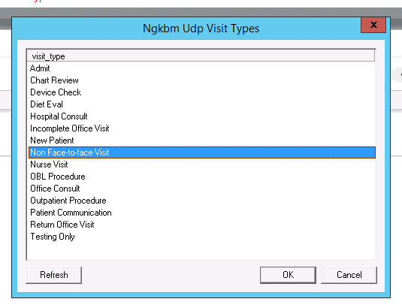

**LOGIN INFORMTION DOXY.ME WEBSITE (DEVICES ARE SET WITH THESE LICENSES):**

|  |  |  |  |  |  |
| --- | --- | --- | --- | --- | --- |
|  |  |  | |  | |
| Iowa Licenses | | | Device | | Illinois Licenses | | Device |
| cvmed3@gmail.com | | | Samsung 10in | | cvmed1b@gmail.com | | Samsung 10in |
| cvmed5b@gmail.com | | | Samsung 10in | | cvmed1b@gmail.com | | Samsung 10in |
| cvmed4@gmail.com | | | Samsung 10in | | cvmedcb1@gmail.com | | Chrome Book |
| cvmed6b@gmail.com | | | samsung 8in | | cvmedcb2@gmail.com | | Chrome Book |
| doxy2@cvmedpc.com | | | EP Ipad 1 | | doxy4@cvmedpc.com | | Doc device |
| doxy3@cvmedpc.com | | | EP Ipad 2 (broke) | | doxy6@cvmedpc.com | | doc device |
| doxy16@cvmepdc.com | | | OUTREACH LAPTOP | | cvmed7@gmail.com | | samsung 8in |
| doxy17@cvmepd.com | | | OUTREACH LAPTOP | | doxy8@cvmedpc.com | | ? |
| doxy18@cvmepdc.com | | | OUTREACH LAPTOP | | doxy9@cvmedpc.com | | ? |
| doxy19@cvmepdc.com | | | ? | | doxy10@cvmepdc.com | | ? |
|  | | |  | | doxy11@cvmepd.com | | ? |
|  | | |  | | doxy12@cvmepdc.com | | ? |
|  | | |  | | doxy13@cvmepd.com | | ? |
|  | | |  | | doxy14@cvmepdc.com | | ? |
|  | | |  | | doxy15@cvmepd.com | | ? |

Passwords are all the same= **Heart13.**

**FINDING THE NON FACE-TO-FACE TEMPLATE IN NEXTGEN:**

* In EMR, on the Intake, SOAP, and Home Page tabs, click on the link called

Non Face-to-face Visit Details

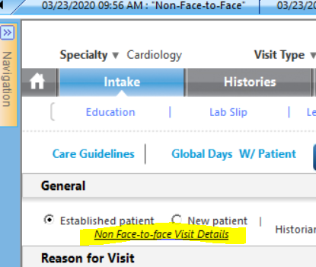

**NON FACE-TO-FACE TEMPLATE IN NEXTGEN EMR**

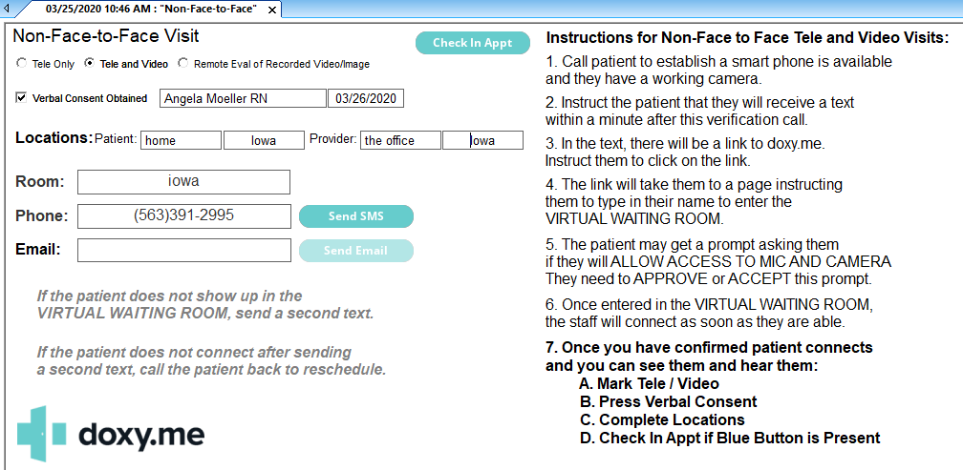

**CVM.DOXY.ME WEBSITE (USING CHROME/FIREFOX/SAFARI) VIDEO SHOWS HERE**

* Patient queue shows when pt.name when they are connected, click Start Call

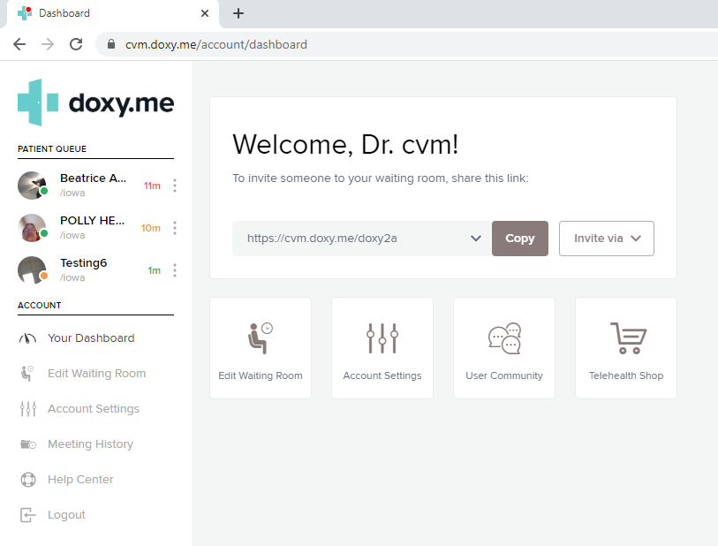

**SUBMITTING CHARGES ON THE FINALIZE TEMPLATE**

* When the Non Face-to-Face visit type is chosen, the Telehealth EM Coding button will display on the Finalize template-click it to show selections
* Choose the correct charge level bullet
* Click the normal Submit button

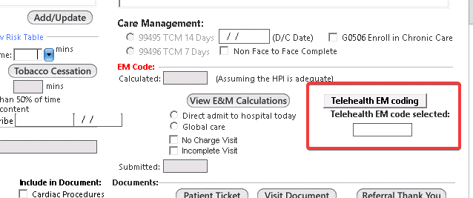

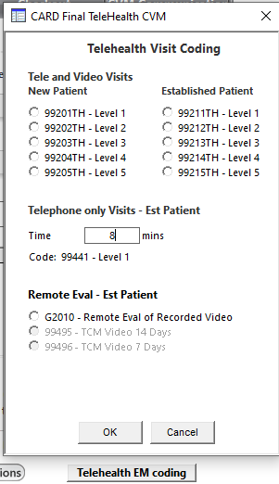

**TELEPHONE ONLY VISITS**

* Clinical staff will check in appt. and reconcile medications prior to the Provider discussion with the pt.
* Telephone visits require documentation of time spent with the Provider doing medical discussion with the pt.
* The Telehealth EM Coding has a box to fill in the total minutes spent. This will auto select the correct level to bill and insert the time spent in the documentation.

**AUTOMATED DOCUMENTATION**

*This non-face-to-face visit was performed using telephone only. The patient was located at home in the state of Iowa. The provider was located at the office in the state of Iowa. A total of 25 minutes was spent on the telephone with the patient in medical discussion.*

*Verbal consent for the non-face-to-face visit was obtained by Angela Moeller RN on 04/03/2020.*

**VIDEO ALTERNATIVES IF DOXY.ME DISCONNECTS**

**FACETIME FOR IPHONE USERS**

* On your iPad tablet or iPhone, Add pt. cell phone number to contacts
* + to do a New FaceTime
* Search for the contact and select them from your contact list
* Click green video button
* If you want to block your identity from showing, go to Settings
  + FaceTime Settings within Settings
  + Click on Apple ID and Sign Out from your ID
  + Click Sign in with New Apple ID
  + Enter [doxy2@cvmedpc.com](mailto:doxy2@cvmedpc.com) then return/enter
  + Password Heart13. Enter.
  + Make sure there is no check mark by your phone number
  + Wait for a bit…your screen will change and you’ll be ready to close Settings and start the FaceTime call.

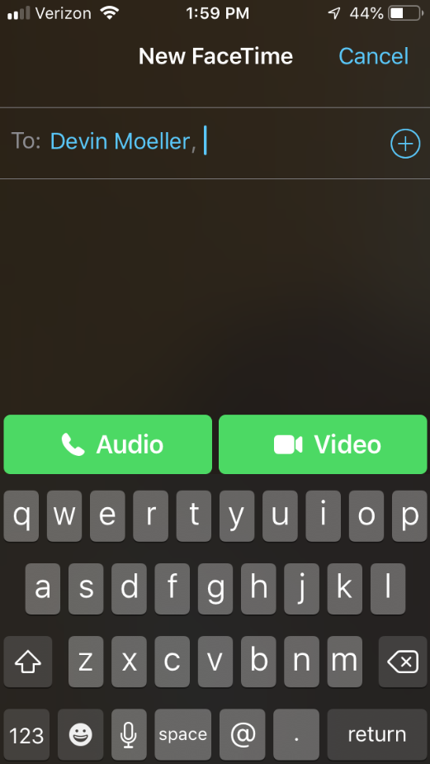 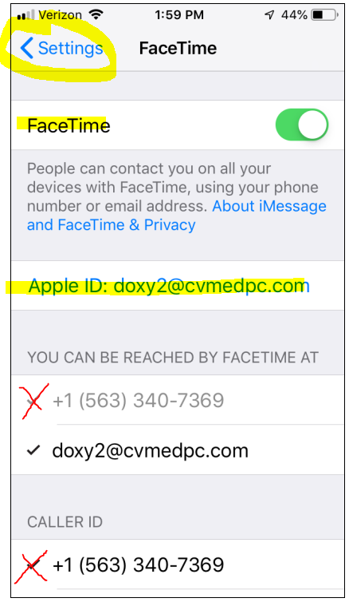

**INSTRUCTIONS FOR VERIFYING INSURANCE**

1. Name and address (usually found on back of card) of Insurance

2. Name of the insured (patient, spouse etc) and birthdate

3. ID number

4. Group number – if they have it

5. Is this the patient’s primary or secondary insurance?

6. Cards can be emailed to: [InsuranceCards@cvmedpc.com](mailto:InsuranceCards@cvmedpc.com)

**INSTRUCTIONS FOR INSTALLING GOOGLE DUO**

There is a button to click that sends the pt. a text link to download the Google Duo app on the Non Face-to-Face template

[https://duo.app.goo.gl/D7kNQek](https://protect-us.mimecast.com/s/nxVwC2k9q5IoAYASnPQRH?domain=duo.app.goo.gl)

* This app will show your personal phone number to the pt.
* Providers need to download the app as well
* Get the app by going to the Apple APP store or Google Play store and search Google Duo
* You will need to make several entries:
  + Accept terms
  + Give access to microphone, camera, and Contacts
  + Allow notifications
  + Enter your name, email, phone number as prompted
* Once the app is set up, the pt’s. cell number needs to be entered to your Contacts
* If the pt. already has Google Duo installed you are ready to start the call
* Open the installed app and search Contacts, choose the pt.
* Click the blue button Video Call.
* If the pt. does not have the app already installed, go to the Non Face-to-Face template
* Verify the phone number is the correct cell number for the pt.
* Click the Send SMS (Duo) button at the bottom-this sends a text message to the pt. with a link to install the app.
* The pt. will need to follow the same set up steps as described above.

