GOOGLE DUO VIDEO SOLUTION FOR ANDROID USERS

If doxy.me video fails and the pt. does not have an iPhone, Google Duo may be an option for the video call.
****Note—Google Duo will show your phone number to the pt. when you place the call.
(Clinical staff will enter the appt., check in, create encounter, and do med reconciliation.)
- Get the app by going to the Apple APP store or Google Play store and search Google Duo. It looks like this:

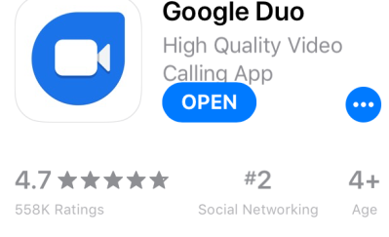
- You will need to make several entries:
  - Accept terms
  - Give access to microphone, camera, and Contacts
  - Allow notifications
  - Enter your name, email, phone number as prompted
- Once the app is set up, the pt’s. cell number needs to be entered to your Contacts
- If the pt. already has Google Duo installed you are ready to start the call
- Open the installed app and search Contacts, choose the pt.
- Click the blue button Video Call.
- If the pt. does not have the app already installed, go to the Non Face-to-Face template
- Verify the phone number is the correct cell number for the pt.
- Click the Send SMS (Duo) button at the bottom-this sends a text message to the pt. with a link to install the app.
- The pt. will need to follow the same set up steps as described above.

