HOW TO SET UP FACETIME TO PROTECT YOUR PRIVATE IDENTITY

BLOCK YOUR IDENTITY SET UP
- Go to iPhone Settings
- FaceTime Settings within Settings
- Click on Apple ID and Sign Out from your ID
- Click Sign in with New Apple ID
- Enter doxy2@cvmedpc.com then return/enter
- Password Heart13. Enter.
- Make sure there is no check mark by your phone number
- Wait for a bit…your screen will change and you’ll be ready to close Settings and start the FaceTime call.

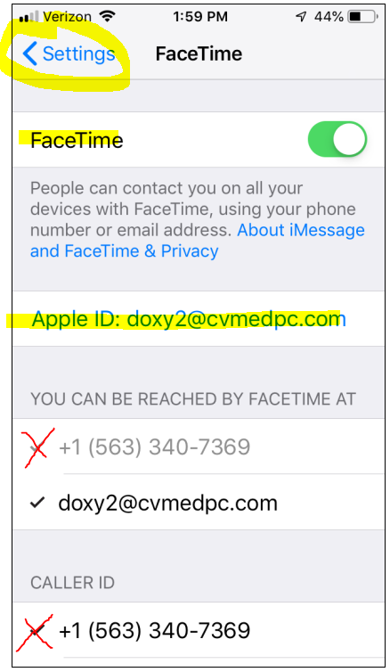
To watch a youtube video of Kevin Stutting showing the process go to this link:
https://www.youtube.com/watch?v=6UCQv2AyMvI
USING FACETIME WITH IPHONES—
- On your iPad tablet or iPhone, Add pt. cell phone number to Contacts
- Open FaceTime with the video camera icon and click + to do a New FaceTime
- Search for the contact and select them from your contact list
- Click green video camera button

