ACCESSING DOXY.ME FROM HOME TO INITIATE A VIDEO VISIT—

- On your laptop or tablet, go to Chrome, Firefox, Safari browser, pull up the cvm.doxy.me site. Avoid Internet Explorer.

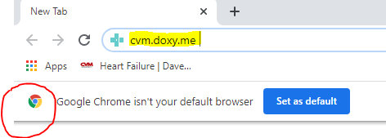
- Click on Provider Login
- Sign in with the CVM user license that has been assigned to you for the day (license will be sent daily via text) and password Heart13. Only use your assigned license so you do not interfere with someone else’s connection.

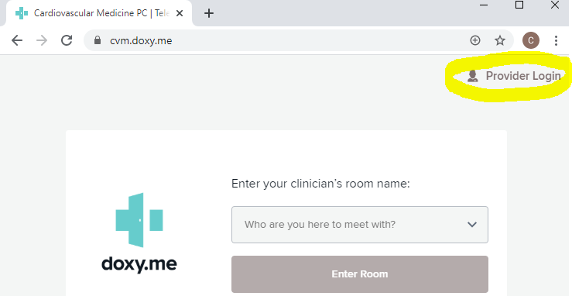
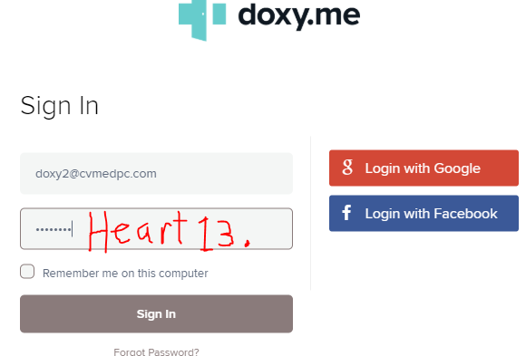

- Open NextGen visit encounter Non-Face-to-Face Visit template (the template should already be available in the encounter, pt. will be prepped by MA staff)
- (The phone number displayed defaults to their cell number, but if the pt. has given instructions to use an alternate number, click on the phone number in the box to show the other options, and select the preferred number for the visit.)
- By the cell phone number click the blue Send SMS button-this sends a text to the pt. with the link to doxy.me
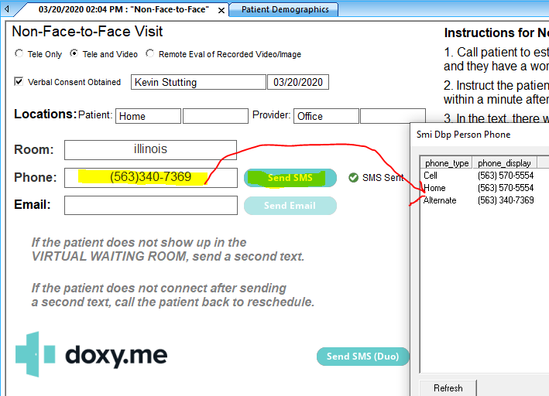
- Go back to your Chrome browser where you are logged into doxy.me to wait for the pt. to connect
- If you have a red banner or it says No Access to Webcam, check your devices’ settings to turn on the camera and microphone-(it’s best to do this step before texting the pt.)
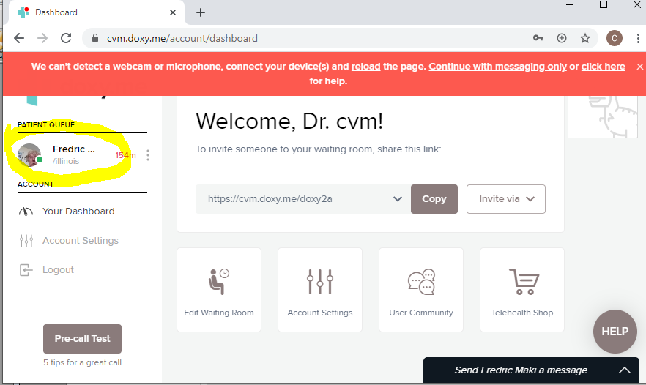
- Watch for the pt. to enter the Patient Queue “Waiting Room” in the upper left corner
- Click on their name and then click Start Call
- Help troubleshoot any video/audio issues with the pt. (may need to ask if their camera is enabled, if sound is turned up, etc.)
- After the introduction, pause the video feed by clicking on the camera icon to improve performance and prevent loss of connectivity
- Call can be “paused” if necessary with the Pause icon ll
- Click the name in the upper left and Start Call when ready to reconnect again
- After connecting, pause video feed again
- When the call is complete, click the red phone receiver button to hang up

If the pt. does not appear in the Patient Queue, re-send the text, and if they still don’t respond, call the pt.

